**Prerequisites:**

MATLAB 2017a or later versions

**Library:**

PHATE MATLAB library <https://github.com/KrishnaswamyLab/PHATE>

Please add all scripts in the “Scripts” folder to MATLAB search path or download scripts from (<https://github.com/CrairLab/GUI_dimReduction/tree/master>).

**Example data:**

This is one example data included “IC_105_105x_10power_filtered_cropped.mat”, which is a cropped movie across the tonotopic axis mentioned in the final report. You can test the GUI with this movie.

**Quick user guide:**

1. Type “GUI_dimReduction” in Matlab. Click load movie and load a movie (in 3D: 2d + time)
2. Click “Use default parameters” underneath
3. Click “Run dimReduction”
4. After the feedback signals analysis finished, Click “Correpond Maps” at the bottom

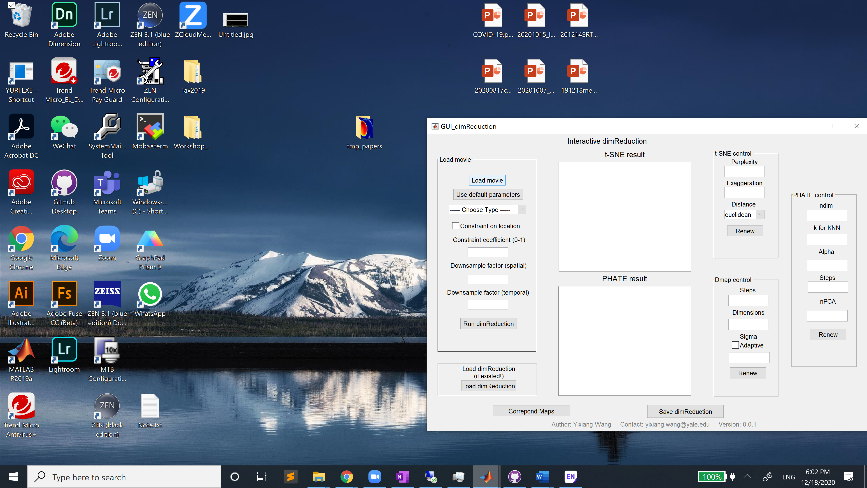

1. Choose an embedding result (tSNE, PHATE or diffusion maps). Click “Run CorrespondMap”
2. In the pop-up figure (Window “Figure 2” below), use the brush function to interact with embedded points and corresponding pixels in the original movie will be colored.

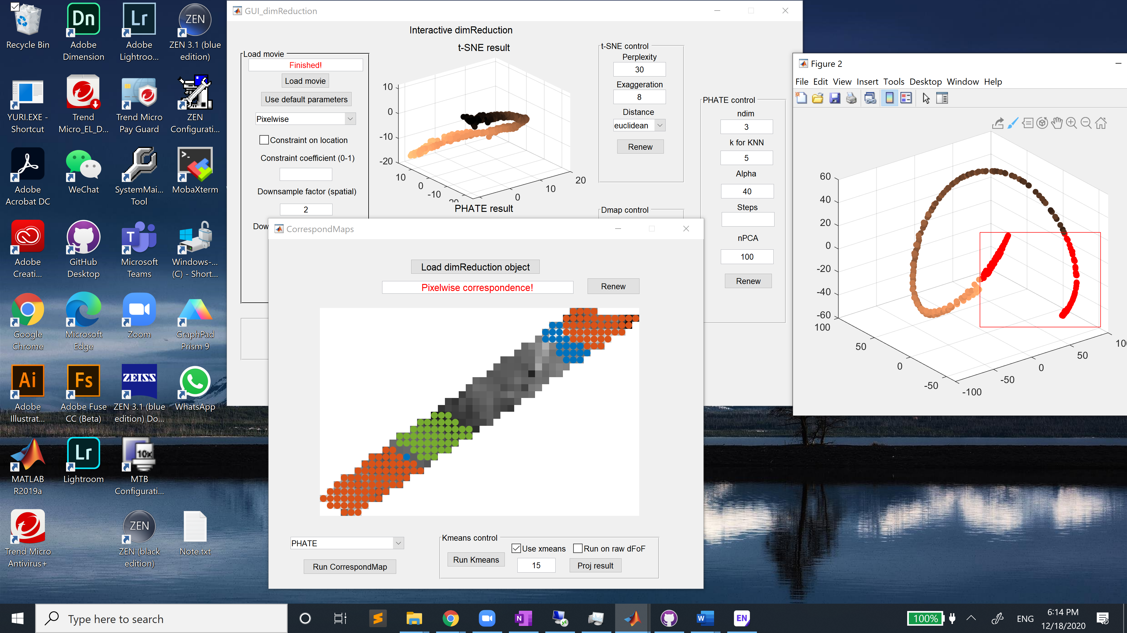

1. For spectral clustering, choose “Diffusion maps” in the popup menu and then click “Run Kmeans”. One can select the maximum number of clusters, whether to use xmeans criterion etc.
2. After the analysis is done, click “Proj result” to color pixels with the spectral clustering result.

